MODULE-9 (APPIUM TESTING)
- Write an Appium Program to connect with emulator and open APIdemo.app application on your emulator.
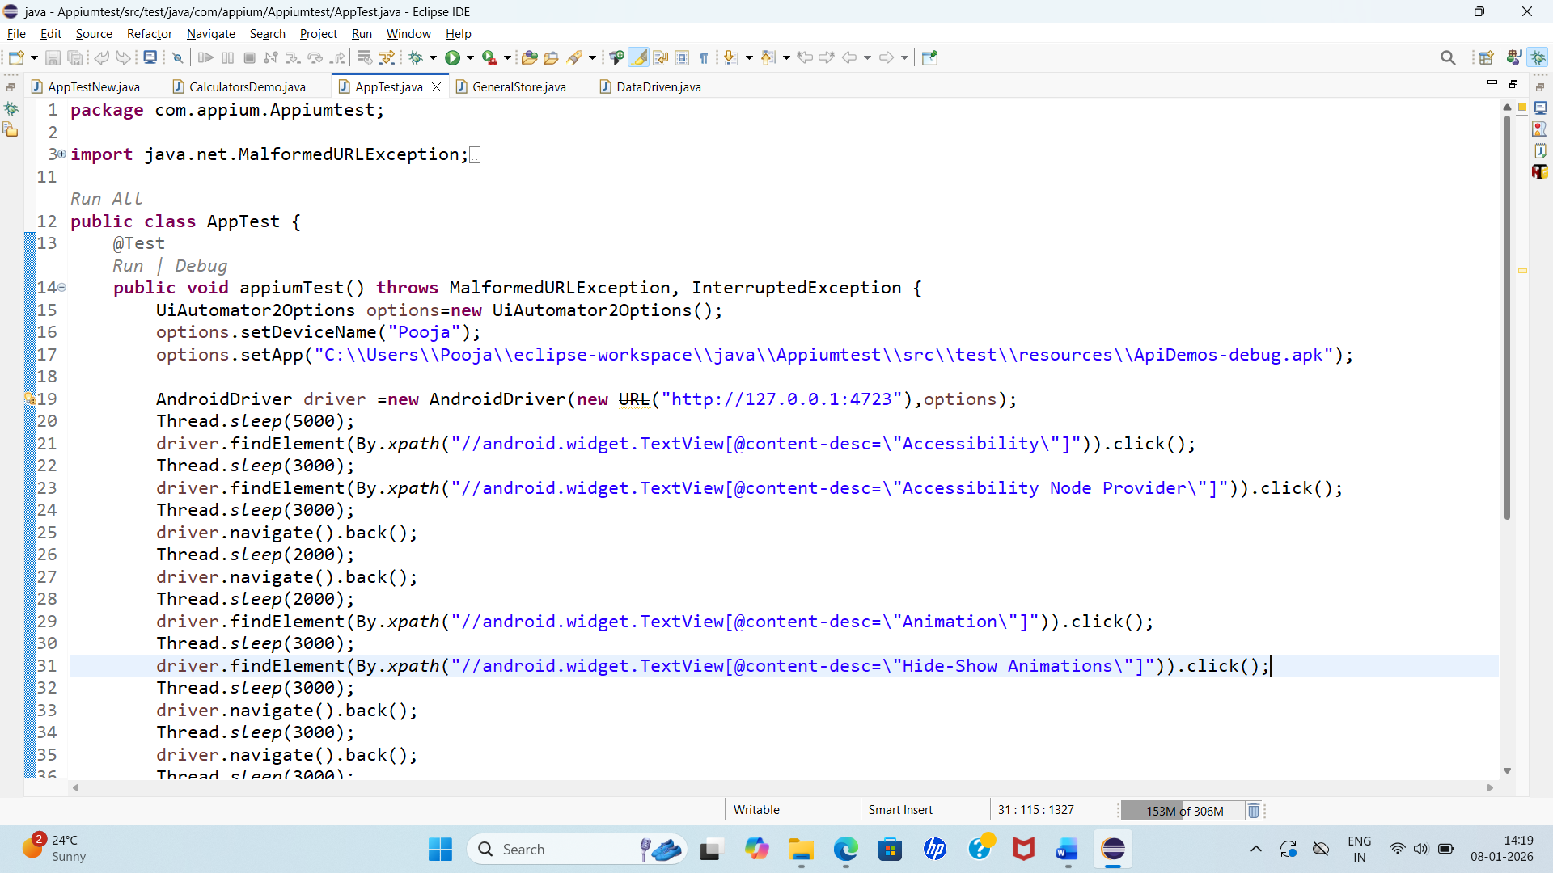

- Write an Appium Program to connect with emulator wit ecommerce based application using Generalstore.app to perform locators like name, dropdown etc.

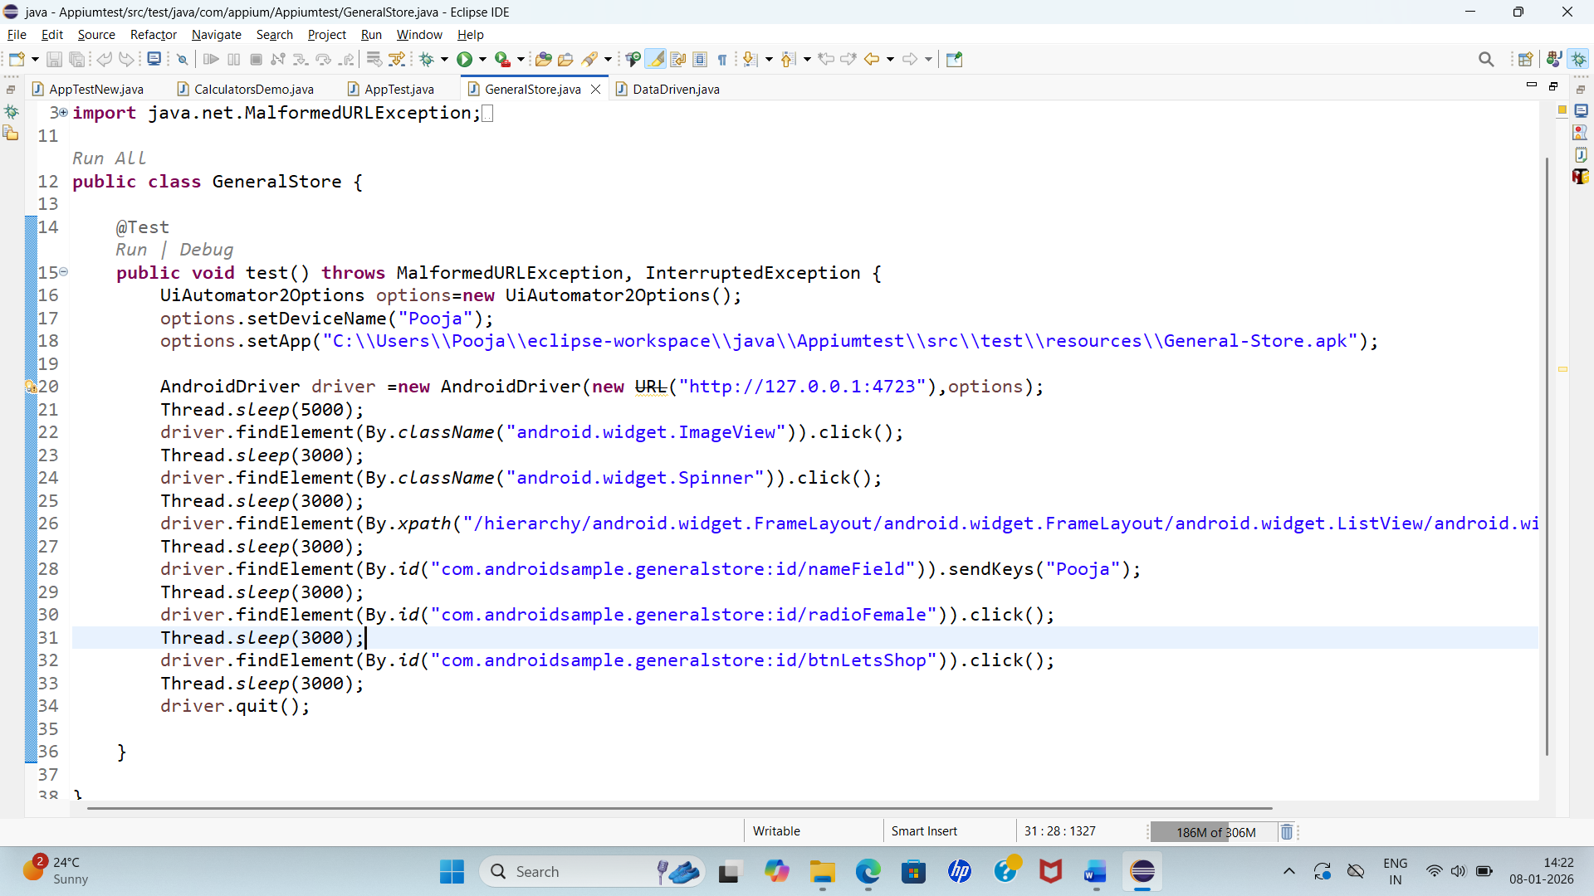

- Write an Appium Program to connect with realdevice using APIDemo.app to perform longpress to open to side menu.
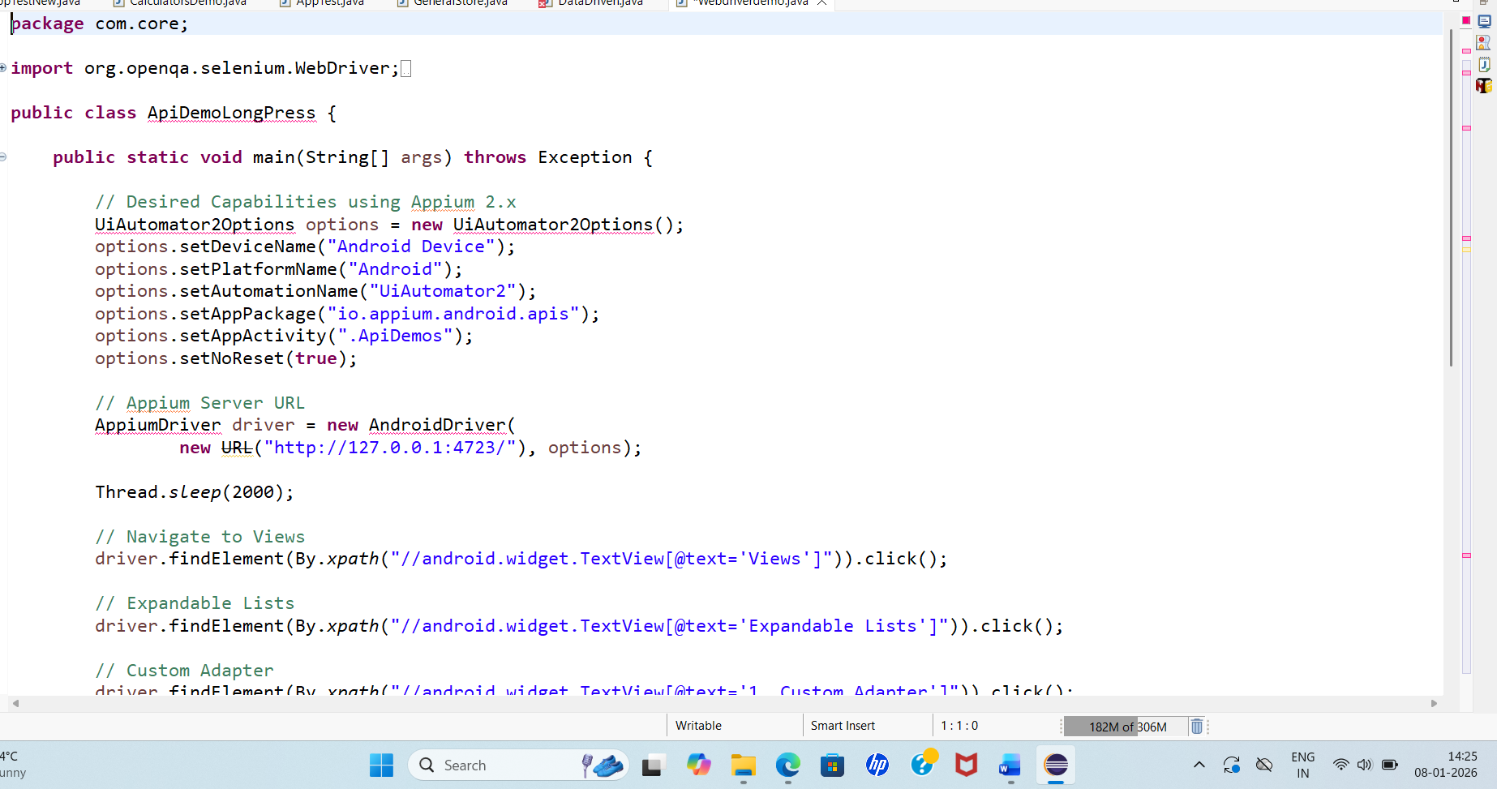
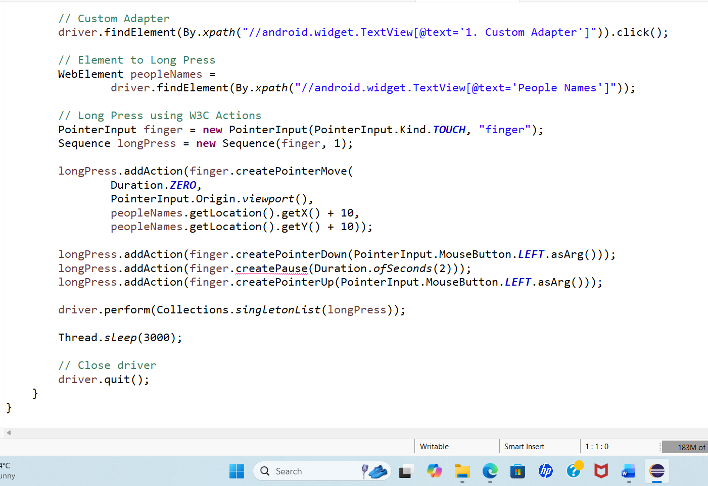

- Write an Appium Program to connect with realdevice using APIDemo.app to open the calculator and calculate all the operation like (addition, substraction, multiplication, division).
